# Design manual

Yu Feng z5094935

## User control flow:

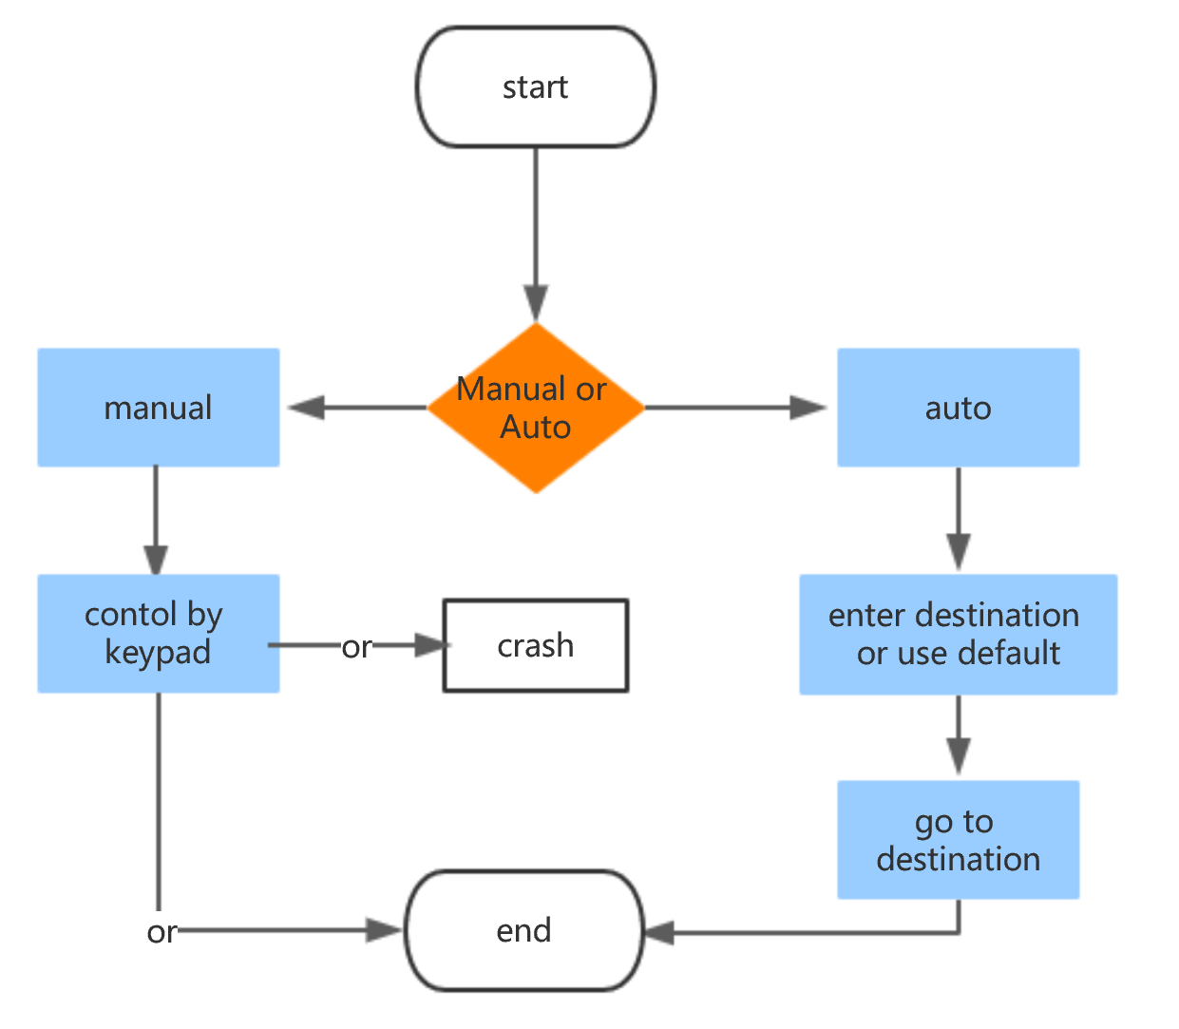

**Figure 1**

## Control flow and data structures:

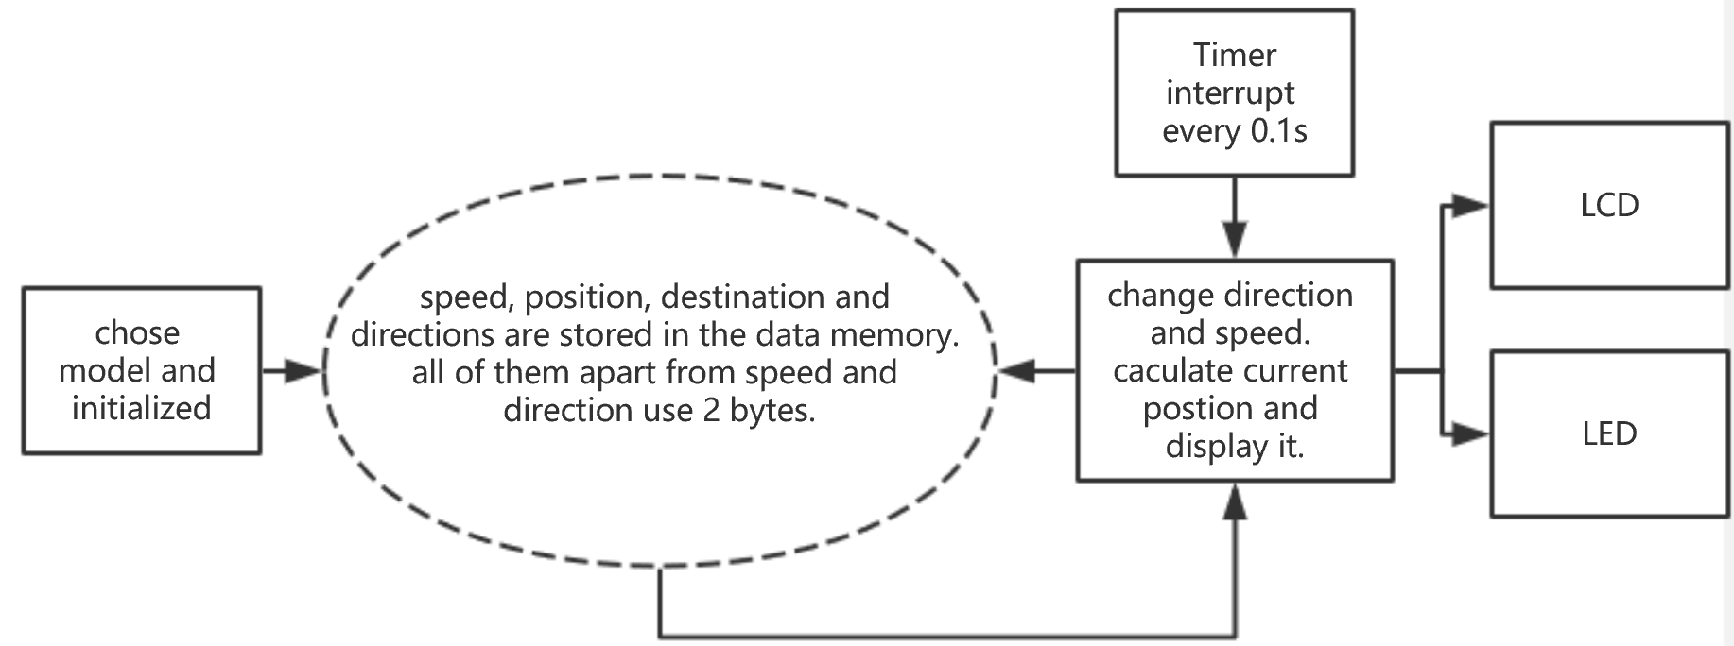

Figure 2

Data:

direction cost 8 bits:

High 4 bits is UP (0010), DOWN (0000), FORWARD (0001).

Low 5 bits is North (0001), South (0011), East (0010), West (0000).

Position x, y, z cost 2 bytes each:

x, y: 0 – 500(cm). z: 0-100(cm)

speed cost 1byte:

0, 1, 2, 3, 4

Control button:

Choose nodule: A button is auto nodule, press any button else will enter manual nodule.

Manual nodule: keypad control action, pb0 and pb1 control speed.

Auto nodule: keypad input destination and speed.

Direction control:

Button 4 and 6 in keypad indicate turning left and right. Low bits in direction will decrease by 1 if 4 is pressed and it will increase 1 if 6 is pressed.

Button 2 and 8 are going up and down.

Calculate position:

Timer3 interrupt program for every 0.1 second. And during the interruption, program will recall “update_postion” function, which will change the position value according current speed and direction. PB0 and PB1 is two interrupt, they will increase or decrease helicopter’s speed.

Final statue:

When ! (0<postion_x<500 and 0<postion_y<500 and 0<postion_x<100), the helicopter would crash, led bar flashes. Otherwise, when # button is pressed, helicopter land. And LCD displays the duration and distance in this voyage.

## Module specification and algorithms:

There are 6 parts in my projects: Main, calculate, keypad, LCD, macros.

1. Main: it the main function of my program, include initialized variables, interrupts and call other function.
2. Calculate: update_postion function calculate current position. Determine whether crash or landed successfully.
3. Control:
   1. control direction: turn right, turn left, go up and down
   2. change speed: speed up and down
   3. auto polite: go to the destination automatically.
4. Keypad:
   1. Get_key: get input from keypad.
   2. have_got_key: if nothing is pressed, recall get_key, until some button are pressed, store the value of button into the register.
5. LCD:

Some function to control LCD display

1. Macro:

Some useful macro, like store and load data to 2 bytes data memory, do LCD display.